

LAB TASK 3

Question 1:
CODE | EXPLANATION
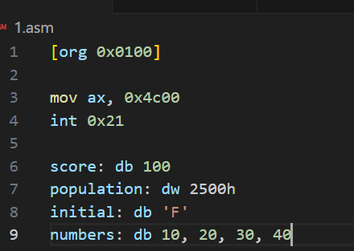 | - score: db 100-> stores value of 100(decimal value) in define byte ‘score’. This will occupy 1byte with the value of 0064h.  - population: dw 2500h: Stores the value 9472(decimal value) in define word ‘population’. This will occupy 2byte with the value of 2500h.  - initial: db ‘F’: stores the value 70(ASCII for ‘F’ in decimal) in define word variable ‘initial. This will occupy 1 byte with the value 0046h.  - numbers: db 10,20,30,40: Stores the values in define byte variable.
Output
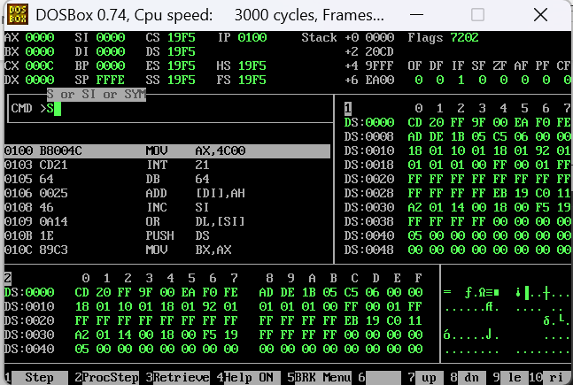

Memory usage Table
Variable | Type | Size (byte) | Address | Value
Score | Define byte | 1 | 0100 | 0064h / 100d
Population | Define word | 2 | 0101-0102 | 2500h / 9472d
Initial | Define byte | 1 | 0103 | 0046h / 79d
Number[0] | Define byte | 1 | 0104 | 000Ah / 10
Number[1] | Define byte | 1 | 0105 | 0014h / 20
Number[2] | Define byte | 1 | 0106 | 001Eh / 30
Number[3] | Define byte | 1 | 0107 | 0028h / 40

Question 2:
Code
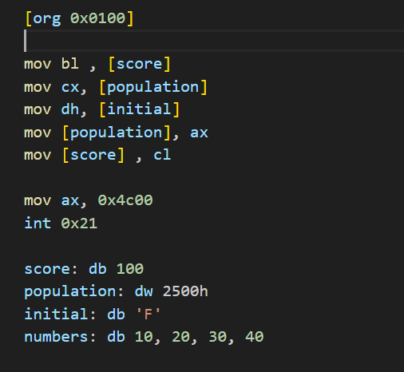

OUTPUT | EXPLANATION
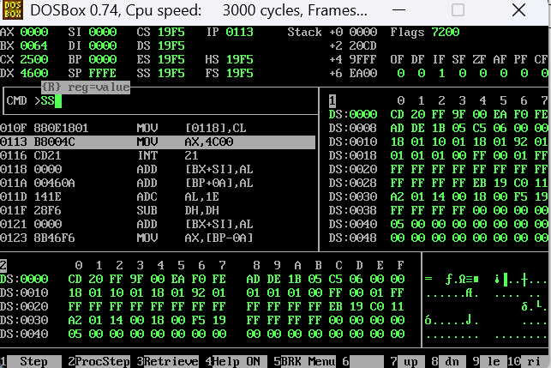 | - score value [0064] is stored in bl register, population value [2500] stored in cx register and initial value [0046] stored in dh register.  - The value of ax is moved in ‘population’  - The value stored in cl register is moved in score variable.

Question 3:
Code | Debugger
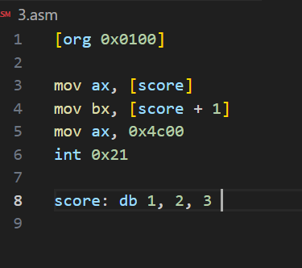 | 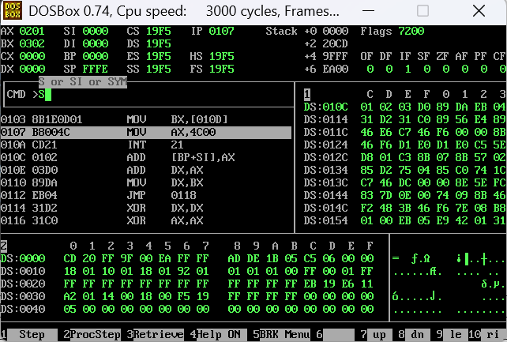

Explanation of the problem | Possible solution
- We are using db and it only store 1 byte number. But when we are moving the value of store [0] in the register ax which can store 16-bit number. Therefore, there is the memory mismatch.  - In the output showing on the right, 0201 is stored in ax register instead of 0001. | - To fix this memory mismatch we have two solutions  - Either use define word instead of define byte.  - Or use al/ah register instead of ax

Question 4:
CODE
[org 0x0100]  mov [var1], 99h  mov ax, [var2]  mov bl, var1  mov ax, 0x4c00  int ox21  var1 dw 1234h  var2 db 12h | - Mov [var1], 99h: program doesn’t know whether 99h is 8-bit or 16-bit.  - Mov ax, [var2]: var2 is define byte (8-bit)number and we are moving it to ax which will store 16-bit value, use ah/al instead of ax.  - mov bl, var1: we are moving address to bl not value, also var1 stores 16-bit number and bl can store upto 8 bit only

